PREPARATION AND MAINTEANCE OF ZOHO BOOKS FOR

TRAVEL TREXS

INTRODUCTION:

Zoho Books is an online accounting application that gives you complete visibility of your ﬁnances and helps you manage the money moving in and out of your business. ZohoBooks can simply be deﬁned as “accounting for rest of us”. You need not be an accountant to manage your business and make informed ﬁnancial decisions.

OBJECTIVES: What is the objective of ZohoBooks?

ZohoBooks is your one-stop platform for managing your accounting tasks and organizing your transactions. It's a single secure location to keep up with your company's bills and invoices, reconcile your bank statements, control your spending, oversee projects, and eliminate sales tax compliance worries.

Why do we need ZohoBooks?

It allows you to manage your projects from budgeting to logging time and invoicing customers eectively. Moreover, ZohoBooks Software lets you record the time spent on tasks and avoid overbilling and underbilling your customers.

PROBLEMS:

EMPATHY MAP: 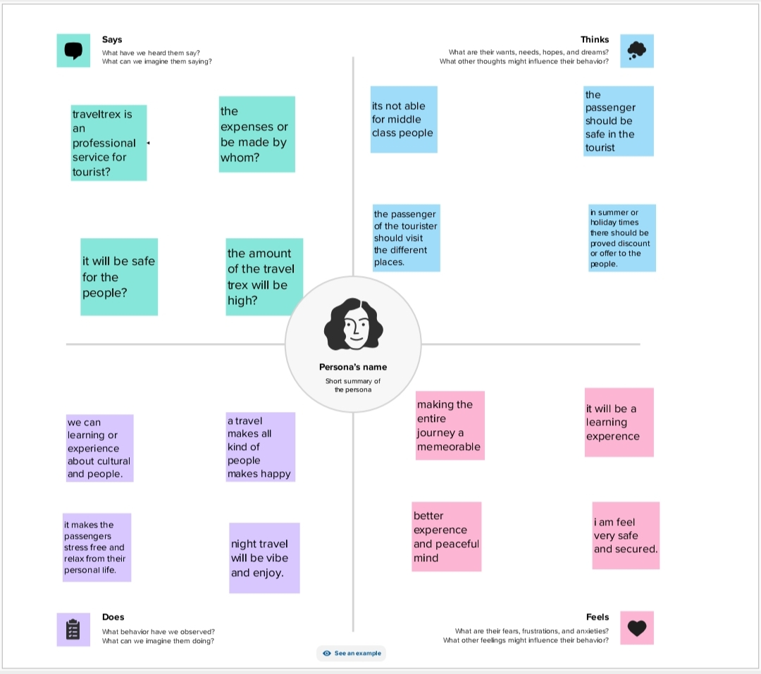

BRAINSTORMING:

FEATURES:

Functions in Projects

1. Create and Send Project Quotes.
2. Invoice Customers for Projects.
3. Record Project Expenses.
4. Create Retainer Invoice for Projects.
5. Bill the Vendors for a Project.
6. Manual Journals.
7. Bulk Update Line Items.

ADVANTAGES:

A typical tour package will usually include plenty of destinations. Chances are that going to all these places on your own would cost a lot more, mainly because travel agents and tourism companies have good connections with the hotels and transportation companies, and also because they get maximum discounts for sending groups rather than individuals or single families.

1. One of the biggest advantages is of course the convenience. As earlier suggested, planning for a full-fledged trip and visiting various places will take quite a lot of planning and due diligence. But when you opt for a tour package, you can just sit CONCLUSION:
2. To conclude, ZohoBooks is easy to understand and its conﬁguration is quick and easy. The automation of the system is great and you save a lot of time.
3. Always back and relax — at least as far as planning is concerned.
4. You will be able to relax and enjoy your travel and the places without having to worry about the tickets, and hotel reservations in your next stop.
5. Tour packages can be a great option when you are looking to plan a honeymoon or travel with your family. A poorly planned trip can be quite embarrassing as well as stressful; therefore, going with a reputable travel company might be a safer option.
6. Safety is another big advantage of tour packages. When you are doing the planning, and choosing the destinations or activities to do, you might pick out a place or activity that might have some potential risks that you’d rather avoid. Travel companies know places inside out, and they will usually choose risk-free destinations and activities, keeping in mind the age and preferences of the participants.

DISADVANTAGES

1. The biggest disadvantage of a tour package is the lack of control. You need to follow the guidelines and a strict schedule. You cannot extend your stay in a certain place even if you love it. Similarly you cannot move to the next place if there’s nothing to be excited about, before the scheduled time.
2. You need to be extra careful while choosing one of these packages. The aforementioned advantages can easily turn into disadvantages if you don’t choose the right company.
3. You will have to be a little flexible with your dates and timings, in case you are looking to leave and arrive back on certain dates. You might find it hard to find an appropriate trip with the same time frame.